PRACTICAL NO 2

Estimation of project metrics for garage management system

For this practical I refer Virtual lab

**Link**

[**Virtual Labs**](https://se-iitkgp.vlabs.ac.in/exp/project-metrics/)

**Project Estimation for Veterinary Hospital Database Management System (VDBMS) using COCOMO**

**1. Introduction**

The **Veterinary Hospital Database Management System (VDBMS)** is designed to automate pet registration, outpatient and inpatient management, pharmacy tracking, billing, and staff management in veterinary hospitals. The project will be a **web-based** application running within the hospital network. Given the team size (**small**) and experience (**high**), the project is classified as **"organic"** under the COCOMO model.

Based on expert evaluation, the estimated **size of the project** is approximately **12 KLOC (12,000 lines of code)**, which serves as the basis for estimation of project effort, duration, and cost.

**2. Effort and Duration Estimation Using Basic COCOMO**

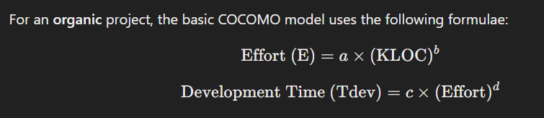

Where:

* **a = 2.4, b = 1.05, c = 2.5, d = 0.38** (for organic projects).
* **KLOC = 12** (estimated).

**2.1 Effort Estimation**

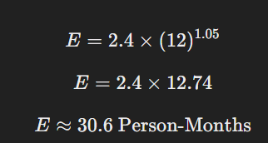

Thus, the estimated effort is **31 Person-Months (PM)**.

**2.2 Development Time Estimation**

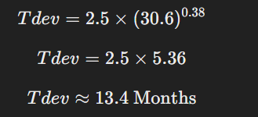

Thus, the estimated time required for project completion is **13.4 months (approx. 13 months)**.

However, **basic COCOMO** does not account for various project-specific factors. To improve accuracy, we refine these estimates using the **intermediate COCOMO model**.

**3. Effort and Duration Estimation Using Intermediate COCOMO**

**3.1 Determining the Effort Adjustment Factor (EAF)**

In the **Intermediate COCOMO model**, effort is adjusted using an **Effort Adjustment Factor (EAF)**. The EAF is calculated by multiplying **cost driver weights**, considering attributes like product complexity, team experience, tools, and environment.

Based on expert assessment, we assume an **EAF = 0.55** for VDBMS (slightly higher than the SE VLabs Institute project due to additional functionalities like billing and pharmacy tracking).

**3.2 Corrected Effort Estimation**

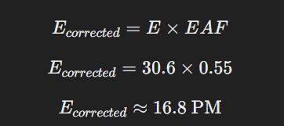

Thus, the **corrected effort** is **17 Person-Months**.

**3.3 Corrected Development Time Estimation**

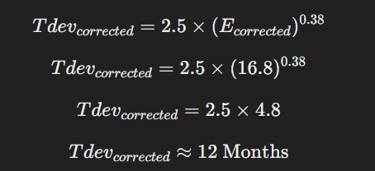

Thus, the **corrected development time** is **12 months**.

**4. Final Project Estimation Summary**

| **Estimation Metric** | **Basic COCOMO** | **Intermediate COCOMO** |
| --- | --- | --- |
| Estimated Effort | **31 PM** | **17 PM** |
| Estimated Development Time | **13 Months** | **12 Months** |
| Effort Adjustment Factor (EAF) | **N/A** | **0.55** |
| KLOC (Estimated) | **12 KLOC** | **12 KLOC** |

**4.1 Key Takeaways**

* Using **Basic COCOMO**, the estimated effort was **31 Person-Months**, requiring **13 months** of development time.
* After refining with **Intermediate COCOMO (EAF = 0.55)**, the effort reduced to **17 Person-Months**, and development time reduced to **12 months**.
* The refined estimate suggests that **a 1-year timeline is sufficient for project completion**.
* Additional refinements using **Complete COCOMO** (if needed) could account for specific **subsystem complexities**.